Sprint 4 Report
SlugFound | Team SlugFound | CSE 115A – Intro to Software Engineering
Sprint Dates: May 23, 2025 – June 6, 2025 | Report Date: June 6, 2025

1. Actions to Stop Doing
The following are practices the team identified during the Sprint 4 retrospective that should be discontinued or reduced going forward.

1.1 Deferring Storage RLS Policies to the End of a Story
The team should stop treating Supabase Storage access policies as a final cleanup step. Sprint 4 added two new upload paths — message images (US 4.4) and profile avatars (US 4.5) — and in both cases the per-user folder RLS policy was written only after the upload UI already worked, briefly leaving buckets open wider than intended during development. Scoping the folder policy alongside the upload code, rather than after it, keeps the secure-by-default property from slipping.

1.2 Re-Implementing Owner-Permission Checks Per Surface
The team should stop duplicating the 'is this the authenticated owner?' check across each new surface. The detail page action bar (US 4.1), the edit/delete route guard (US 4.2), and the status-transition buttons (US 4.3) each re-derived ownership independently, which is error-prone and made the 403 behavior harder to verify consistently. A single shared ownership helper would remove the repetition and give one place to test.

2. Actions to Start Doing
The following are new practices the team identified that should be adopted to improve the development process going forward.

2.1 Build a Shared Storage Upload Helper
The team should start consolidating file uploads behind one helper that handles validation, size and MIME limits, pathing, and old-file cleanup. Three Sprint 4 stories touched Supabase Storage — the item photo swap on edit (US 4.2), message images (US 4.4), and avatars (US 4.5) — each with its own near-identical upload logic. A shared helper would cut duplication and centralize the 5MB/2MB and image-type rules.

2.2 Add Integration Tests for RLS and Access Guards
The team should start writing lightweight integration tests around the security-critical paths now that Jest is in place. The 403 guard on the edit route (US 4.2), the report-table INSERT-only RLS (US 4.6), and the per-user Storage folders (US 4.4, US 4.5) are exactly the kind of behavior that regresses silently. Encoding them as tests makes each subsequent sprint's verification pass cheaper.

2.3 Define a Status-Lifecycle State Machine Up Front
The team should start modeling item status transitions explicitly rather than guarding them with ad-hoc conditionals. US 4.3 introduced the active → claimed → resolved lifecycle with a no-further-transition rule once resolved; expressing the allowed transitions as a small table or state machine would make the disabled-button logic and the account-page reunited count easier to reason about and extend.

3. Actions to Keep Doing
The following are current practices the team found effective and intends to continue.

3.1 Regular Scheduled Meetings
The Monday lab, Wednesday evening, and Friday midday cadence continued to keep the team aligned. With seven stories in scope this sprint, the regular check-ins were essential for coordinating the many small, interdependent surfaces — detail page, edit flow, status badges, and the map view — without collisions.

3.2 Component Reuse Across Pages
Reuse paid off again. The status badge and muted-overlay treatment from US 4.3 dropped directly onto the existing Item Card, and US 4.7's Map/List view reused the react-leaflet setup and lat/lng columns first built in Sprint 3 (US 3.2), letting the carried-over map work land with no rebuild. The initials-avatar fallback was extended in place for US 4.5 rather than replaced.

3.3 Clear Initial Task Ownership
Assigning leads to distinct pillars — the item detail and CRUD surfaces, the messaging and media work, profile and moderation, and the map view — again kept the parallel workstreams from colliding and gave each feature a clear technical point of contact, which mattered given the unusually high story count this sprint.

4. Work Completed / Not Completed

4.1 User Stories Completed
ID | Priority / Pts | User Story | Est. Hours | Status
US 4.1 | High / 5 pts | Full item detail page with photos, map, poster info, and message button | 9 | Completed
US 4.2 | High / 5 pts | Owner edit and delete of a post, with confirmation and updated_at trigger | 8 | Completed
US 4.3 | High / 5 pts | Mark a post as Claimed or Resolved with visual treatment and filter | 7 | Completed
US 4.4 | Med / 5 pts | Send images in messages via Supabase Storage | 8 | Completed
US 4.5 | Med / 3 pts | Edit profile — display name and avatar photo | 6 | Completed
US 4.6 | Low / 2 pts | Flag an item post as inappropriate (reports table + modal) | 5 | Completed
US 4.7 | Med / 3 pts | Map view toggle for browsing geotagged items on the UCSC campus | 6 | Completed

Implementation notes:
- US 4.7 (Map/List toggle) is the story carried over from Sprint 3 (originally US 3.5). It was delivered in full this sprint, reusing the react-leaflet + OpenStreetMap setup and the lat/lng columns from US 3.2, and is credited toward Sprint 4's completed work.
- US 4.4 and US 4.5 both build on the existing Supabase Storage layer, adding the message-images and avatars buckets respectively, each scoped to per-user folders via Storage RLS. The send-button enable/disable logic in US 4.4 allows image-only, text-only, or combined messages as specified.
- US 4.6 shipped with its stretch goal: the reported_flag column and the 3-report SQL trigger that hides over-reported items from listings while keeping them reachable by direct URL behind a warning banner.

4.2 User Stories Not Completed
All seven user stories planned for Sprint 4 were completed and merged to main with passing builds. The map-view story carried over from Sprint 3 was also closed out this sprint, leaving no outstanding carryover.

5. Work Completion Rate

5.1 Sprint 4 Summary
Metric | Value
User stories planned | 7
Total user stories completed | 7 of 7
Story points completed | 28 of 28 pts
Ideal work hours planned | 49 hrs
Ideal work hours completed | 49 of 49 hrs
Total calendar days in sprint | 14 days (May 23 – June 6)
User stories per day | 7 ÷ 14 = 0.50 stories/day
Ideal work hours per day | 49 ÷ 14 = 3.50 hrs/day

5.2 Cumulative Averages (Sprints 1–4)
Across all four sprints to date, the team completed 23 user stories and 179 ideal work hours over 56 calendar days. Cumulative figures count completed work only; the map-view story planned in Sprint 3 is credited to Sprint 4, the sprint in which it was finished.
Metric | Value
Total user stories (S1–S4) | 6 + 6 + 4 + 7 = 23
Total ideal work hours (S1–S4) | 38 + 46 + 46 + 49 = 179 hrs
Total calendar days (S1–S4) | 56 days
Average user stories per day | 23 ÷ 56 = 0.41 stories/day
Average ideal work hours per day | 179 ÷ 56 = 3.20 hrs/day

The final Sprint 4 burnup chart will be presented during the lab session and emailed to the TA and professor as required.

5.3 Sprint 4 Burnup Chart
The chart below tracks cumulative story points completed against the total planned scope of 28 points across the 14-day sprint. The actual line steps up as each user story is completed and reaches the full 28 points by the end of the sprint, with no carryover gap — every planned story was delivered.
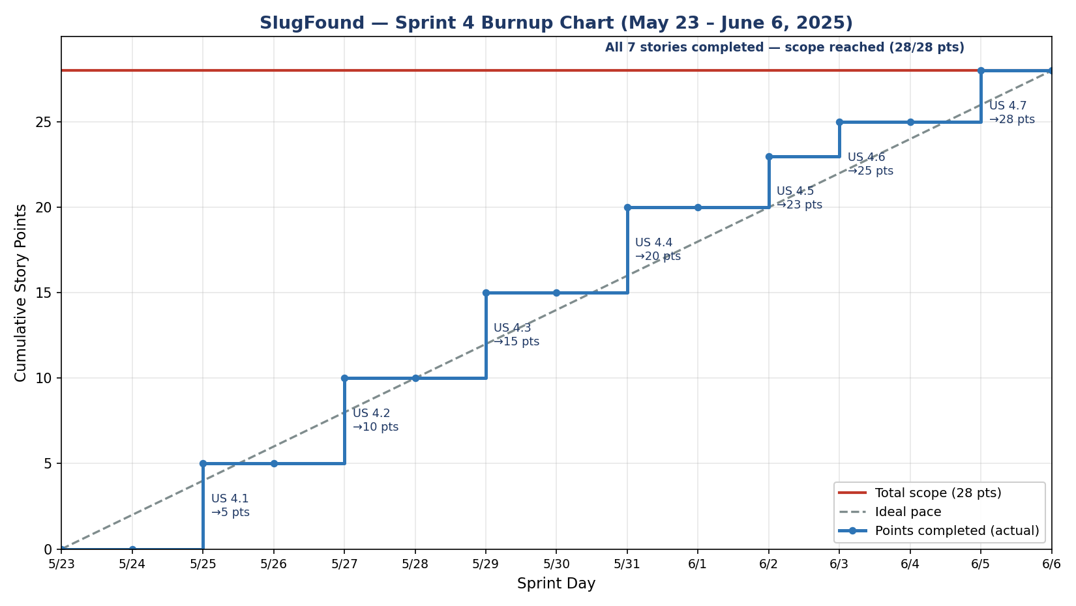
Figure 1. Sprint 4 burnup — cumulative story points vs. total scope (May 23 – June 6, 2025).

6. Team
Team Member | Email | Role(s)
Bardia Nasab | bnasab@ucsc.edu | Scrum Master
Colin Posat | cposat@ucsc.edu | Developer, UI/UX Lead
Sam Madinya | smadinya@ucsc.edu | Developer
Aidan Nguyen | anguy480@ucsc.edu | Developer

